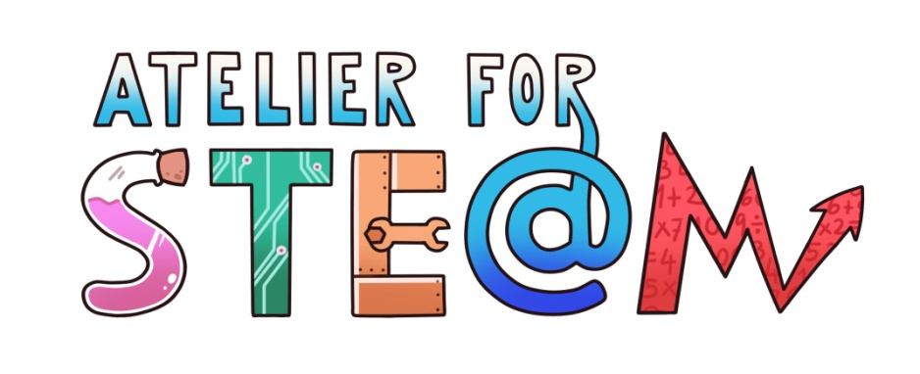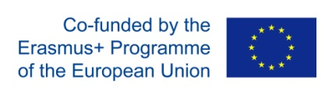

STEM Discovery Campaign 2021
“Atelier for STE(A)M Competition”
-Terms and Conditions-

STEM Discovery Campaign 2021
“Atelier for STE(A)M Competition”

I. Competition Duration: The Competition will start on the 1st of February 2021 and end on the 30th of April 2021 at noon (11:59am Central European Summer Time (CEST)).

II. Eligibility: Open to all primary and secondary school teachers for primary/secondary school students working in countries of the European Unionor associated to the European Unionwith a legal residence in one of these. Participation in the Competition is subject to these Rules and “Atelier for STE(A)M” Erasmus+ project coordinator decisions, which are final and binding in all respects and not subject to appeal.

III. To Enter: During the submission period of the competition indicated in section I, participants can submit their entries which:

- focus on the topic “The color of Science”

- have a STE(A)M vision, that is look for the relation between Art (or Humanities) with STEM topics.

- develop 21st Century skills;
- make STEM learning as exciting and engaging as possible;
- allow creativity and exploration;
- motivate pupils to plan, predict, test, problem-solve, analyse, and explore, all while developing career-readiness skills;
- spark creativity, develop critical thinking skills, and ignite career possibilities;
- emphasize the importance of STEM education and careers

-show how they have adapted the lesson plan to remote learning approach.

- To participate in the competition:

Step 1: Design a scenario or lesson plan by filling the template we provide in the annex B.

Step 2: Apply your activity with your students, evaluating the design and explaining the main conclusions and tips for other teachers who want to use with their students too. Provide us with some pictures or videos to report how the application was.

Step 3: Send us the template, the conclusions, the evidences and all the material you want to include to the next email address: atelier@colegiopedropoveda.org before 30th April 2021.
Don’t forget to include your personal information (name, e-mail, school address, town, country)

Take into account that our topic is “The colours of Science” and we want to develop an integrated vision of the STEM subjects together with Art and Humanities approach (STEAM).

Some ideas could be the chemistry of pigments, the colours of light (fireworks, espectrum), Art and Natural pigments, the colours of food and health, the colours of art under different lights, the colours in paper, the colours of money, illusions with the colour, the colour of temperature, the colours of Nature and many more.
If you organize activities related to the scenario or lesson plan as a kind of dissemination of it, you can also include some information about the activity and this information will be taken into account.

The language of the report should be English.

Please make sure that all links with relevant material are available for view and download until the end of the evaluation phase (see more details in Annex 1. Copyrights and legal issues). Email address you provide in the submission and reporting form has to be valid.

IV. Entry Restrictions: There is a limit of two submissions for the competition by the same person.

DO NOT submit the same activity neither resource more than once. DO NOT use the same resource(s) to create several learning activities.
A given e-mail account may only be used by one person to participate in the competition.
Any dispute as to identity any of the prize winners will be resolved by “Atelier for STEAM project” coordinators in its sole discretion.

V. Content Restrictions. Submitted content must comply with the following criteria:
(a) Content must be original and neither copied, as a whole or partly, nor rephrased from any other source;
(b) Content must be truthful;
(c) Content must not violate the rights of any third party;
(d) Content must not be inappropriate or unfit for publication (e.g., include nudity, obscenity or hate speech);
(e) If your submission shows faces, please be aware that you must be in possession of the signed authorisation of all persons appearing in the videos and/or pictures. In addition, for underage students you must get their legal guardians’ agreement before using their images.

Please be aware that EUN will request signed authorizations for all persons appearing on your video/image submitted to the competition if the submission is selected to be published on the portal (short-listed and winners).

VI. Licence of the content: Entrant accepts that the submitted content follows a Creative Commons License of Attribution-ShareAlike 4.0 International (CC BY-SA 4.0). Details of this license can be found here: https://creativecommons.org/licenses/by-sa/4.0/
Please be aware that in order to use any copyrighted material – images, music, video – you need to be in possession of the permission of the author in written form. EUN reserves the right to request clarification on the copyrights of the materials submitted to the competition. Please read carefully full details in the Annex 1. Copyrights and legal issues.

VII. Selection of Winners:
At the end of the submission period “Atelier for STEAM” coordinators will select submissions as winners based on the following criteria:

- Relevance to STEM topic and accuracy of the knowledge presented.

- Pedagogical Value: Clear goals and objectives, motivation, presentation of resources, specific learning tasks, adaptability to individual needs will be taken into account during the evaluation process. Impact of the actions undertaken by teachers and students. Judges will be looking for evidence of successful knowledge transfer.
- Relevance of the actions designed and implemented within the project. Contributions should demonstrate a clear link to the competition’s requirements. Moreover, the jury will also consider if the actions undertaken are compatible with students’ age group.
- Originality of entries, pertinence, novelty, creativity and didactical approach, will all be taken into account during the evaluation process. All works should be creative, interesting, attractive and in any other way original.
- Clarity of ideas and conclusions, explaining in a clear way, demonstrating a good understanding of the theme and conveying convincing implementation methods, solutions and messages.

- Effective communication of the project and its results.
- Presentation of entries, style, layout, design and good use of technology will be considered.
Involvement of stakeholders: This evaluation criterion will be focused on the involvement of relevant stakeholders (e.g. companies, science and research centres, educational authorities, municipalities, and/or parents) which bring a benefit to the STEM activities featured in the competition entry. Submissions will be judged based on the effective participation of public and/or private organisations and their integration in the process

The “Atelier for STEAM” jury, composed of the coordinators of every partner in the project, will select 6 winners in total.

VIII. Notification of Winners: Potential winners will be contacted by “Atelier for STEAM” via the contact information provided in the submission forms.
In all cases, in order to remain eligible to be awarded with a prize, a winner must respond to the winner notification contact (i.e., via email or comment, as the case may be) and commence the prize claim procedure within 72 hours of transmission/posting of contact. In the event of noncompliance with these requirements, if a potential winner cannot be reached for any reason (including failure to receive or respond to contact for any reason) or if a potential winner is determined to be ineligible or otherwise in violation of these Terms and Conditions, he/she shall be disqualified and forfeit the prize. In case of prize forfeiture, alternate winner(s) will be selected.

PRIZE: Every winner will receive a power bank and their works will be published in the website of the project.

The following conditions will be applied:
- Prizes will be limited to only one person per winning submission, the one that submitted the content in his/her account. No prize substitution is allowed.

Releases: By accepting a prize, the winner allows “Atelier for STEAM” to use his/her name and winning submission to be disseminated as the results of the competition. In case of any problems during the running of the competition, “Atelier for STEAM” keeps the right to modify any of the previous conditions.

More questions? Send us a message: atelier@colegiopedropoveda.org

Austria, Belgium, Bulgaria, Croatia, Republic of Cyprus, Czech Republic, Denmark, Estonia, Finland, France, Germany, Greece, Hungary, Ireland, Italy, Latvia, Lithuania, Luxembourg, Malta, Netherlands, Poland, Portugal, Romania, Slovakia, Slovenia, Spain, Sweden and the UK.
Albania, Bosnia and Herzegovina, Faroe Islands, Republic of North Macedonia, Georgia, Iceland, Israel, Liechtenstein, Moldova, Montenegro, Norway, Serbia, Switzerland, Turkey and Ukraine.

