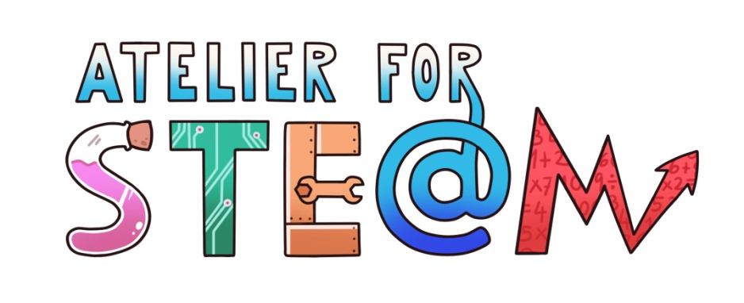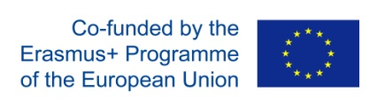

STEM Discovery Campaign 2021
“Atelier for STE(A)M Competition”
Annex 1. Copyrights and legal issues

Annex 1. Copyrights and legal issues
All participants must comply with European and national laws including but not limited to copyright laws, legislation prohibiting the publication of any defamatory, discriminatory or other illegal content or any other similar laws.
The “Atelier for STEAM Competition” (“the Competition”) is organized by the partners of the Erasmus+ project “The colours of Science” (2019-1-ES01-KA229-064239) (“Organizer”). By registering and uploading content, contestants declare that the content submitted is their original work and creation. The Organizer does not assume any responsibility for disputes between persons claiming copyrights of content. By registering and uploading content, each contestant declares that the content does not infringe any third-party rights and that they have obtained all necessary rights and licenses from third parties for the use of any materials. Contestants may not use any music that is not in the public domain or for which they have not acquired the necessary rights and licenses. The contestants will be fully responsible to the Organizer for any breach of the conditions contained in this disclaimer and in particular, will hold the Organizer harmless from any actions brought by third parties.
The Organizer reserves the right to exclude proposals submitted for the Competition if it comes to their knowledge that there are copyright infringements or the content contains defamatory, discriminatory or other illegal material or does not comply with national legislation.
By registering and uploading content, the contestants agree that the Organizer shall have the right to make the content freely available for educational purposes on the web, CD-ROM or in any other media format for a period of three years starting from the date of the close of entries for the Competition.
By registering and uploading content the contestants declare that all identifiable individuals in their entry consented to the use of their image/performance, the submission of the content in this competition, and the use of the content by the Organizer for educational and promotional purposes in all media formats, including the web, for a period of three years from the date of the close of entries for the Competition. Contestants declare that the individuals who have provided content for their submission will sign all necessary documents granting the Organizer, if required by it, the rights free of charge to use the content as indicated above.
For promotional purposes, the winners at national level will have to make available a presentation for the Organizer of their entry in a publicly available format, e.g. a trailer, teaser, screenshot etc. By submitting their content, contestants declare their agreement that the Organizer may freely use this presentation in all media formats in its promotional activities of the award. The Organiser shall have complete discretion as to how they want to claim and exercise these rights.

Privacy Policy
The following statement explains our policy regarding the personal information we collect about you for the purposes of the STEM Discovery Campaign 2021- “Atelier for STEAM” Competition (“Competition”).
• Overview
• Information collection
•Use of collected information
• Length of data storage
• Site security
• Changes within this privacy policy

Overview
The Competition Platform is dedicated to respecting the privacy of its users. Our intention is to provide a secure and safe environment for all users. The following statement outlines the policies by which the Platform collects, manages, and uses the data provided to us by users, and how users of the portal may exercise their rights. Use of the Platform indicates you have read these policies and agree to abide by them.
The Platform is controlled by EUN Partnership AISBL, the legal name for European Schoolnet, which acts as the Data Controller for any personal data collected via the Platform. Contact information for EUN Partnership AISBL can be found below.
Information collection
To serve its users in the best way possible, the Platform requires users to submit the following information as a part of the application for the Competition:
Applicant’s data (Adults): name, surname, email address, country and school or organization (if applicable).
In addition, information such as user IP address, internet service provider (ISP), web browser, operating system, approximate times of use, referring site, email address and any similar data exchanged between a user’s computer and the servers of the Platform will be collected. These will not be linked to specific user accounts except as indicated below.
Finally, aggregate statistics will be collected regularly, including but not limited to the number of users and page statistics during a specific period.
Use of collected information
Personal information provided by the user or collected during usage of the Platform will only be used to:
• Implement the Competition including judging the entries, publishing the names of the winners in the media and awarding the prizes.
• Enable and improve the user experience within this project.
• Send print materials and other items by post on request by members using address details provided by them.

Access to this information is strictly limited to EUN Partnership AISBL, as well as individual experts and judges working for the Organiser. The transfer of specific data to other third parties can be permitted under the specific authorisation of EUN Partnership AISBL acting as the Data Controller; such authorisation will only be granted by the Data Controller to third parties with a legitimate interest in the Competition, including the European Commission. Personal data will only be transferred in accordance with applicable regulations. EUN Partnership AISBL will not divulge your personal data for direct marketing purposes to third parties.
EUN Partnership AISBL will have access to provided account information and can modify and/or delete information as needed to maintain the integrity of the user database or to ensure the proper operation of the Platform.
Length of data storage
Personal data provided by the users of the site or collected during their usage of the site will not be stored by EUN Partnership AISBL in a form allowing the identification of the users for longer than three years after the date of the close of entries for Competition. In addition, registered users may contact the EUN Partnership AISBL as indicated below to terminate their accounts, which will result in the deletion of the personal data that they have provided during registration.
Site security
The Platform has implemented and continues to maintain appropriate technical and management measures to keep your personal information secure and safe from loss, damage, corruption, or deletion.
Changes within this privacy policy
Any and all changes to this privacy policy will be posted here and will take effect upon their publication. If you have any questions or concerns about this privacy policy, at any time, please contact: privacy@eun.org.
Contacting EUN Partnership AISBL
EUN Partnership AISBL is based in Brussels (Belgium). For any questions related to the Platform, including your rights to access, correct and delete your personal information under applicable data protection law, you can contact us:
By e-mail: privacy@eun.org
By mail: EUN Partnership AISBL
Rue de Trèves 61
B-1040 Brussels By phone: +32 2 790 75 75
PLEASE READ CAREFULLY
Please note that we use a third-party processor (Google Drive) to process the submissions to the competition and any personal data relating to it (name, surname, email, phone, address, organisation, school name, country). Such processing will be carried out in accordance with Google Drive's terms and conditions (see https://www.google.com/drive/terms-of-service/).
Any personal data covered by this form will be processed in accordance with the new EU Regulation on Data Protection (GDPR) which came into force on the 25th May 2018.
IMPORTANT NOTE
By completing the submission and reporting forms and sending in your personal data (name, surname, email, phone, address, organisation, school name, country) you are consenting to the processing of your personal data as detailed above.
CONTACTS
Please note that you have the right to contact us at any time and ask us to correct any personal data we hold on you or ask for it to be deleted. If you have any questions regarding this survey, please contact Anastasiya Boiko (anastasiya.boiko@eun.org) or Eleni Myrtsiotiv (eleni.myrtsioti@eun.org).

If you feel that we have not dealt correctly with any personal data we are holding on you (see section above) or wish to make an official complaint, please contact the Belgian Data Protection Authorities:
Belgian Data Protection Authority
Rue de la Presse 35
1000 Bruxelles
+32 (0)2 274 48 00
+32 (0)2 274 48 35
contact@apd-gba.be

