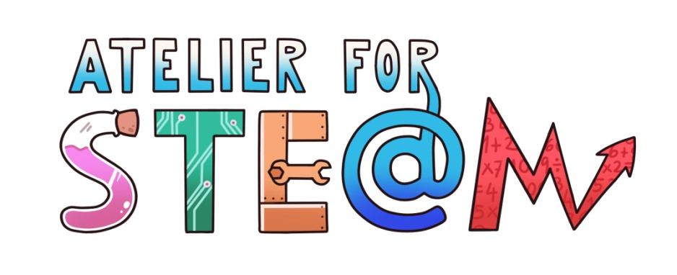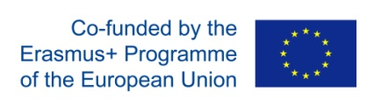

STEM Discovery Campaign 2020
“Atelier for STE(A)M Competition”
-Template for the description of the activity-

Annex 2.

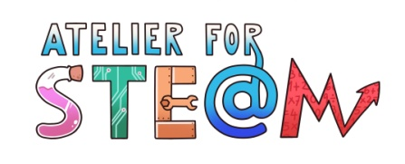 | STE(A)M activity related to “The colours of Science”
Title
Content knowledge (Topics to be worked on)
Methodology
Technology (ICT tools to be used, in its case)
Duration
Target group (age, course)
Resources
Learning Objectives, Skills and competencies

or. (Aims to be accomplished)

Didactic sequence

-Description of every lesson

with added attention to the diversity of students
Evaluation

(what are we going to evaluate, how, whom…)

Conclusions
Improvements

